**SQL Lesson 1: SELECT queries 101**

1.SELECT title FROM movies;

2.SELECT director FROM movies;

3.SELECT title,director FROM movies;

4.SELECT title,year FROM movies;

5.SELECT * FROM movies;

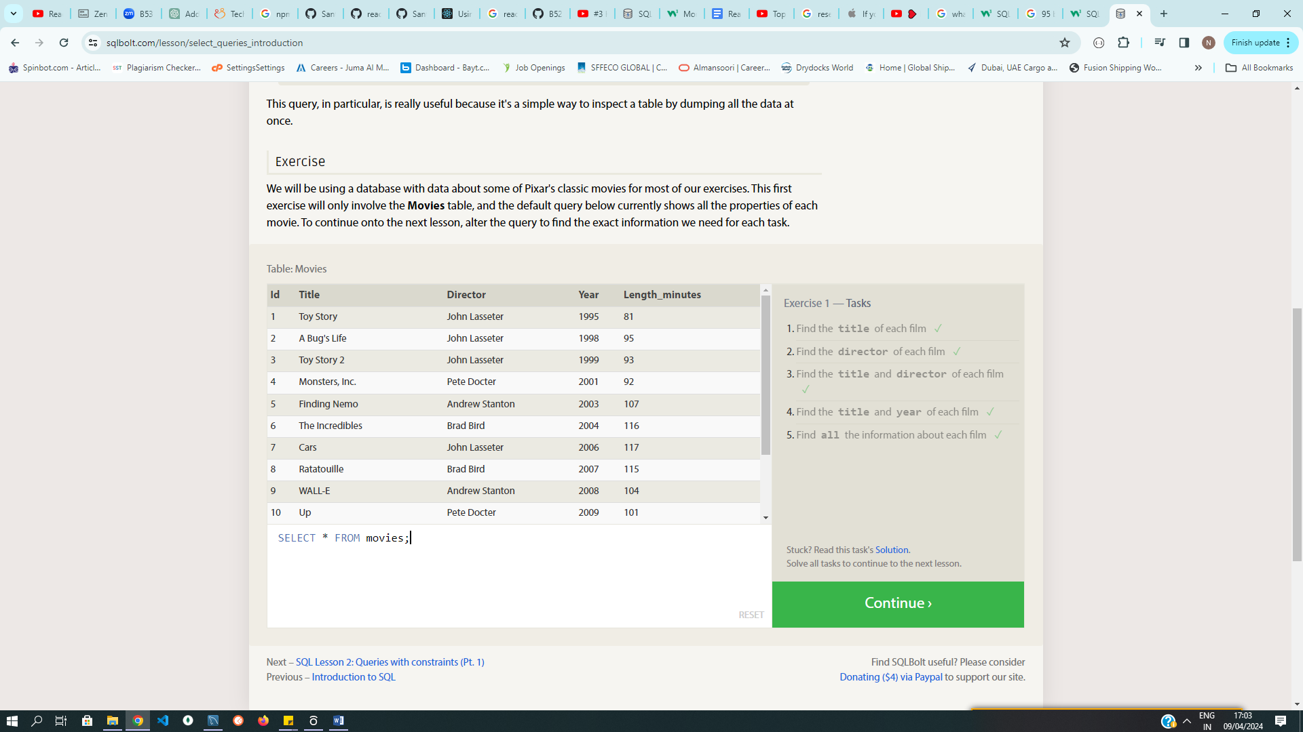

**SQL Lesson 2: Queries with constraints (Pt. 1)**

1.SELECT * FROM movies where id=6;

2.SELECT * FROM movies where year between 2000 and 2010;

3.SELECT * FROM movies where year not between 2000 and 2010;

4.SELECT Title, Year FROM movies where id between 1 and 5 ;

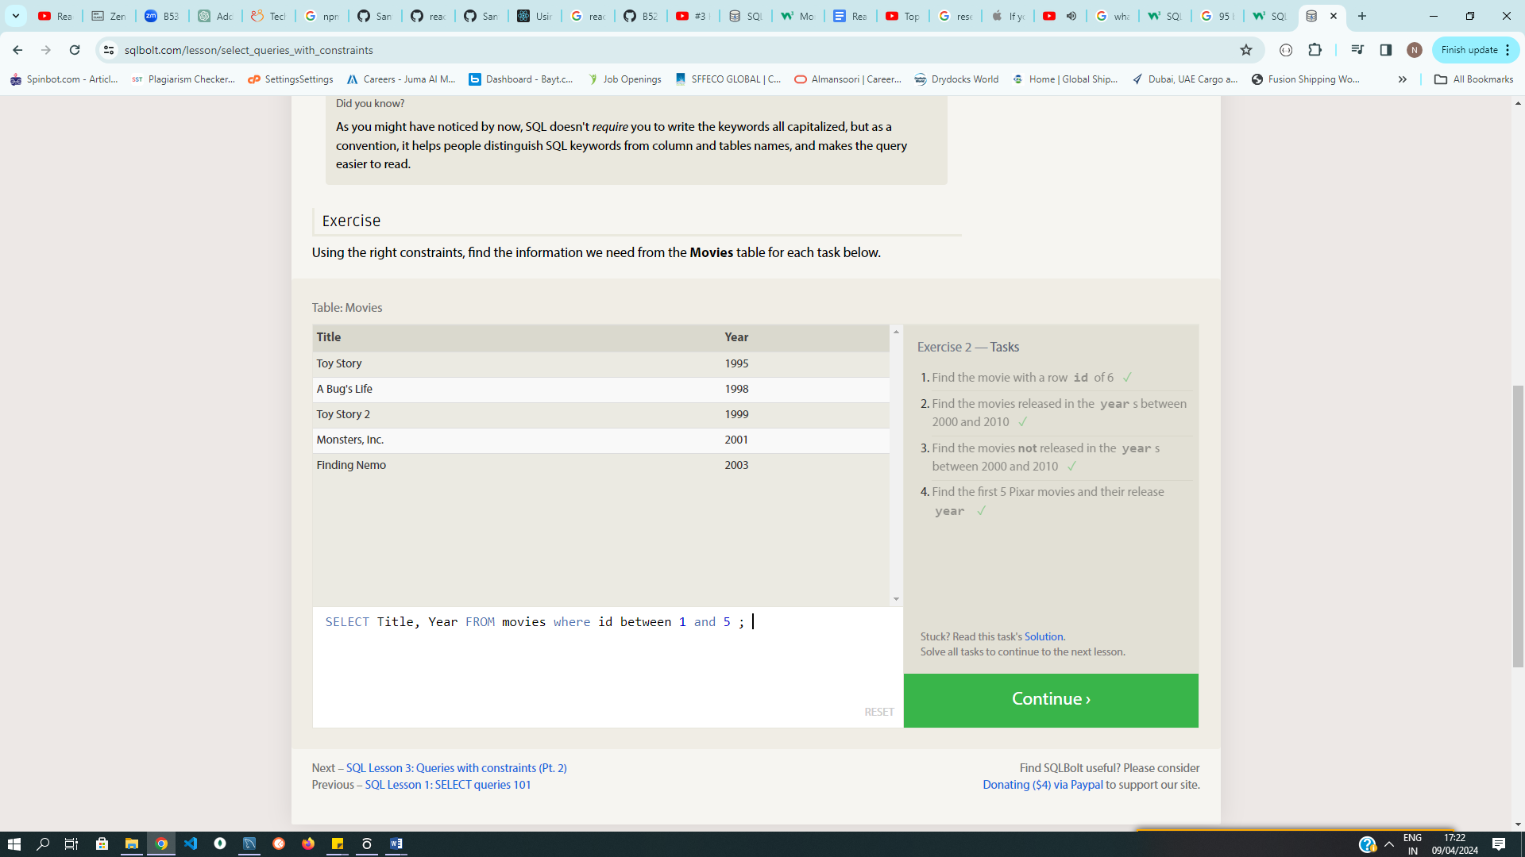

**SQL Lesson 3: Queries with constraints (Pt. 2)**

1.SELECT * FROM movies where Title like "Toy Story%";

2.SELECT * FROM movies where Director like "John Lasseter";

3.SELECT title, director FROM movies where Director != "John Lasseter";

4.SELECT * FROM movies where Title like "WALL-%";  
  
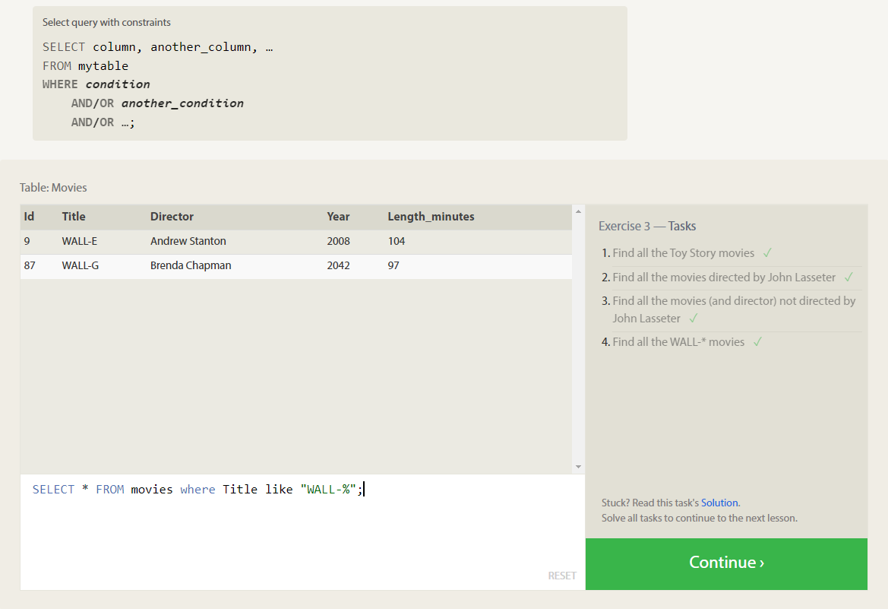

**SQL Lesson 4: Filtering and sorting Query results**

1.SELECT DISTINCT director FROM movies ORDER BY director ASC;

2.SELECT title from movies order by year desc limit 4;  
3.SELECT title from movies order by title asc limit 5;  
4.SELECT title from movies order by title asc limit 5 offset 5;  
  
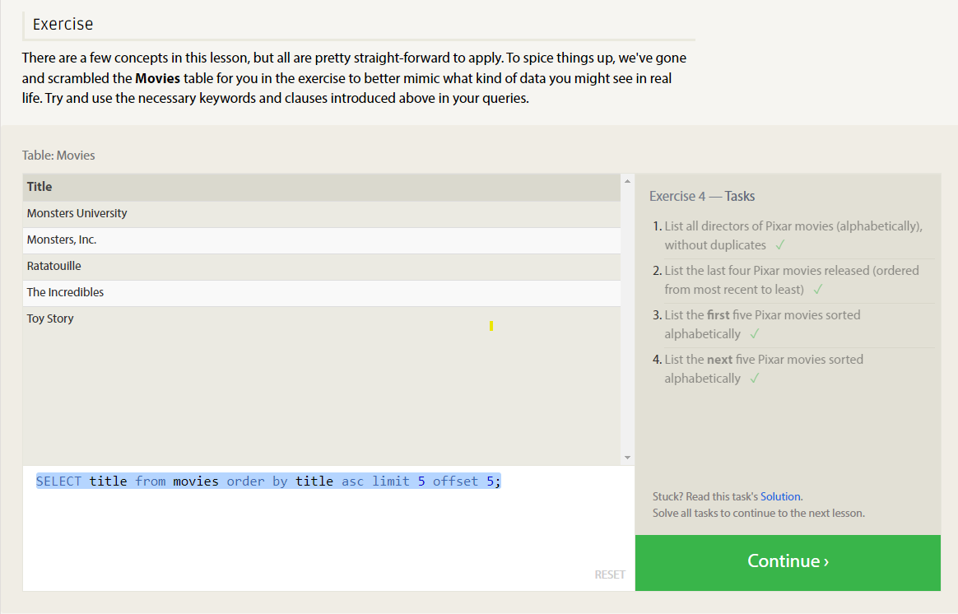

**SQL Review: Simple SELECT Queries**

1.SELECT City, Population FROM North_american_cities WHERE Country = 'Canada';

2.SELECT city FROM north_american_cities where country= "United States" order by latitude desc;

3.SELECT city FROM north_american_cities where longitude < (select longitude from north_american_cities where city="Chicago") order by longitude asc;

4.SELECT city,population FROM north_american_cities where country ="Mexico" order by population desc limit 2;

5.SELECT City, Population FROM North_american_cities WHERE Country = 'United States' ORDER BY Population DESC LIMIT 2 OFFSET 2;

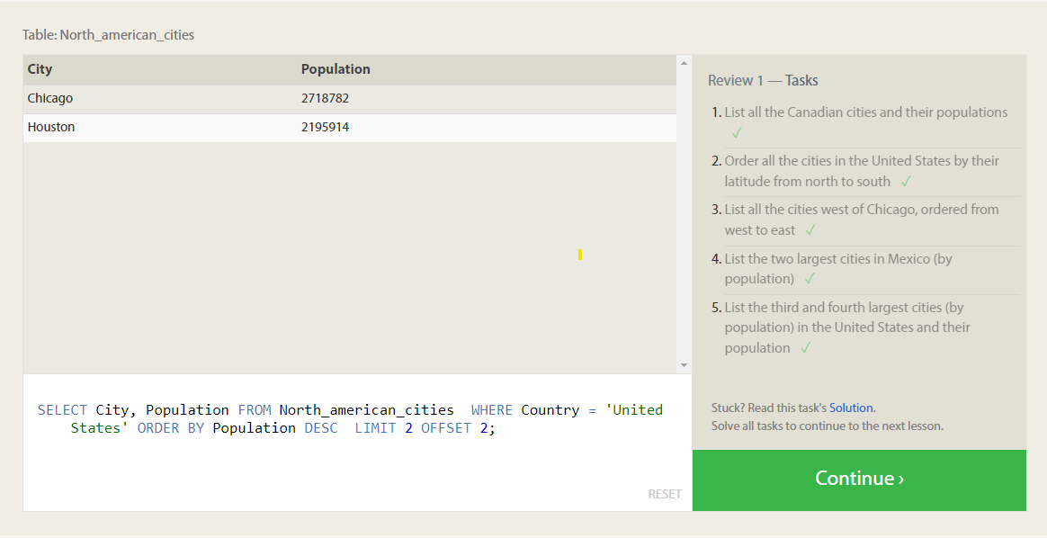

**SQL lesson 6: Multi-table queries with joins:**  
  
1.SELECT Title,Domestic_sales,International_sales FROM movies inner join Boxoffice on movies.id=Boxoffice.Movie_id;

2.SELECT Title,International_sales,Domestic_sales FROM movies inner join Boxoffice on movies.id=Boxoffice.Movie_id where International_sales > Domestic_sales;

3.SELECT Title,Rating FROM movies inner join Boxoffice on movies.id=Boxoffice.Movie_id order by Rating desc;

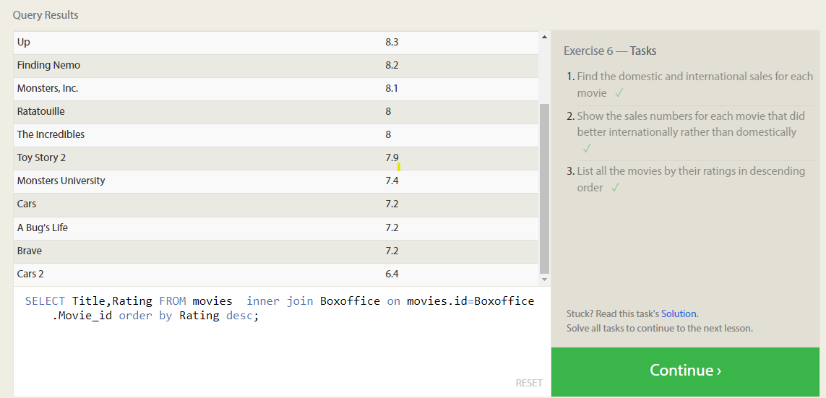

**SQL Lesson 7: Outer Joins:**

1.SELECT Distinct Building,capacity FROM employees inner join Buildings on Building_name = Building;

2.SELECT distinct Building_name,capacity FROM Buildings left join Employees ON Building_name = Building;  
  
3.SELECT distinct Building_name,Role FROM Buildings left join Employees ON Building_name = Building;

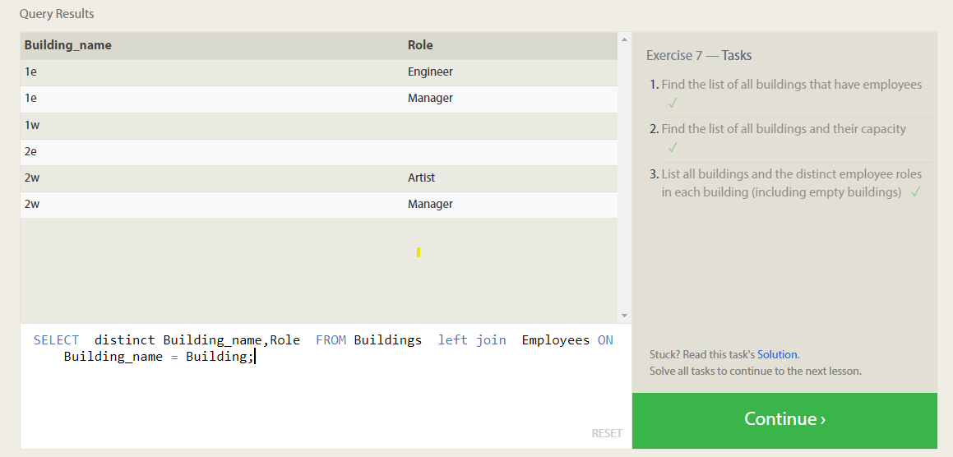

**SQL Lesson 8: A short note on NULLs**

1.SELECT Name, Role FROM employees where Building is Null;

2.SELECT Building_name FROM Buildings left join Employees on Building_name = Building where Building is Null;

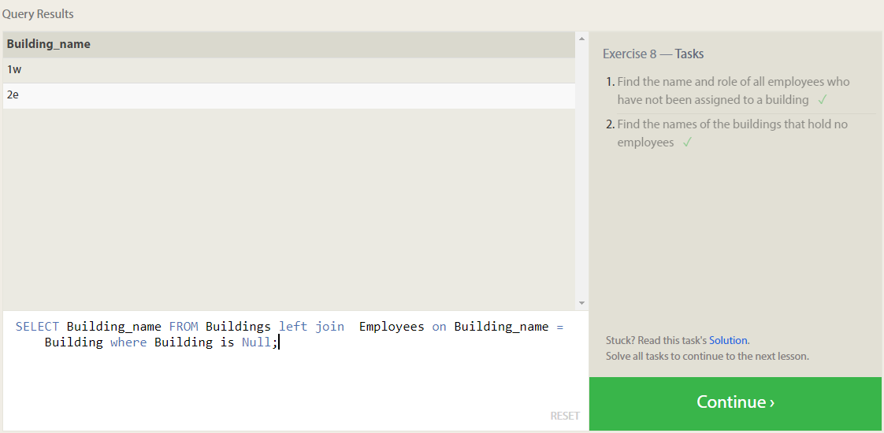

**SQL Lesson 9 : Queries with Expresions:**

1.SELECT Title,Domestic_sales,International_sales,(Domestic_sales + International_sales)/1000000 AS Combined_Sales FROM Movies Inner Join Boxoffice on Movies.Id=Movie_id ;

2.SELECT Title,Rating,(Rating*10) AS Ratings_percent FROM Movies Inner Join Boxoffice on Movies.Id=Movie_id;

3.SELECT Title,year FROM Movies Inner Join Boxoffice on Movies.Id=Movie_id

where year%2=0;

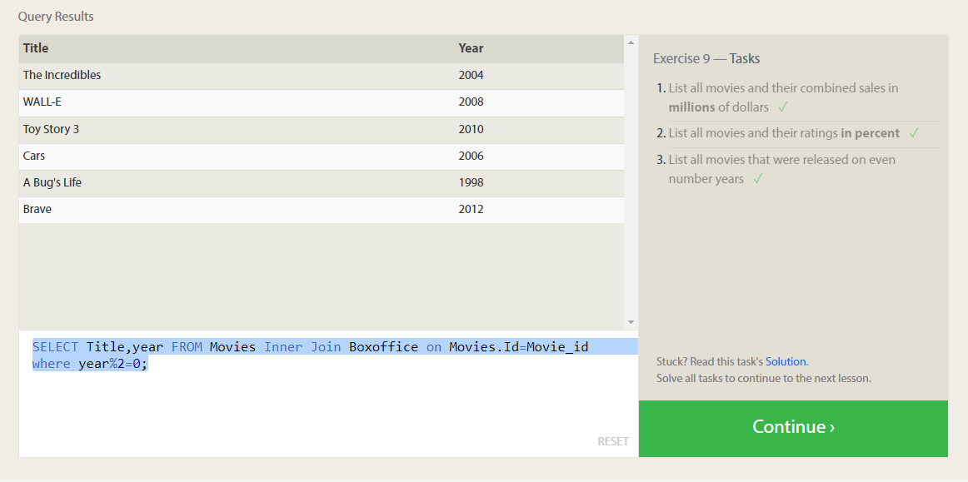

**SQL Lesson 10: Queries with aggregates (Pt. 1)**

1.SELECT MAX(Years_Employed) FROM employees;

2.SELECT Name, Role,Years_Employed,Avg(Years_Employed)as Avg_Year FROM employees Group by Role;

3.SELECT Building,sum(Years_Employed)as Total_Years FROM employees group by Building;

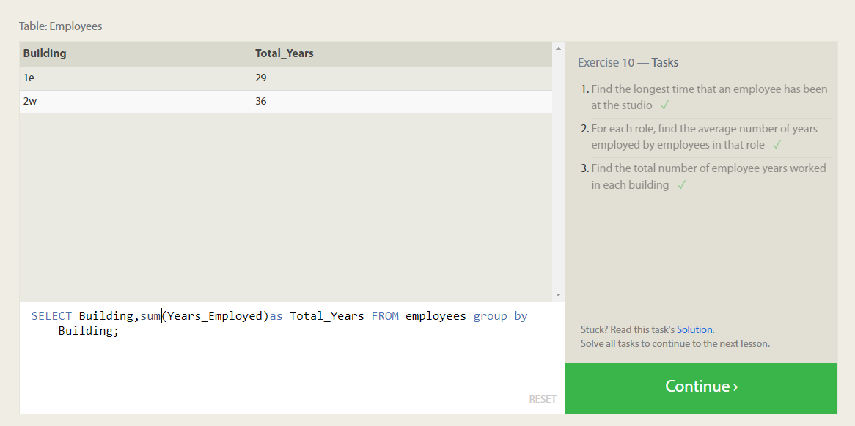

**SQL Lesson 11: Queries with aggregates (Pt. 2)**

1.SELECT Building, COUNT(*) AS Total_Artists FROM Employees WHERE Role = 'Artist';

2.SELECT Role, Count(Name)as Total FROM employees group by role;

3.SELECT Role, sum(years_Employed)as Total FROM employees where role='Engineer';

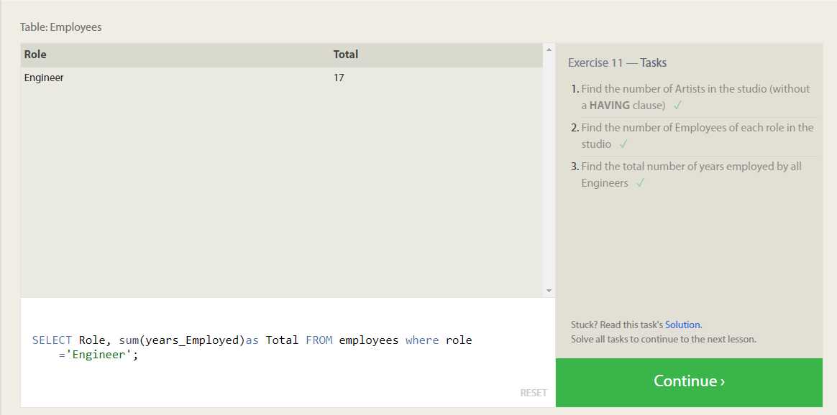

**SQL Lesson 12: Order of execution of a Query**

1.SELECT Director,Count(Title) as Num_Movies from movies group by Director;

2.SELECT Director,sum(Domestic_sales+International_Sales) as Tot_Sales from movies inner join Boxoffice on Movies.Id=Movie_id group by Director;

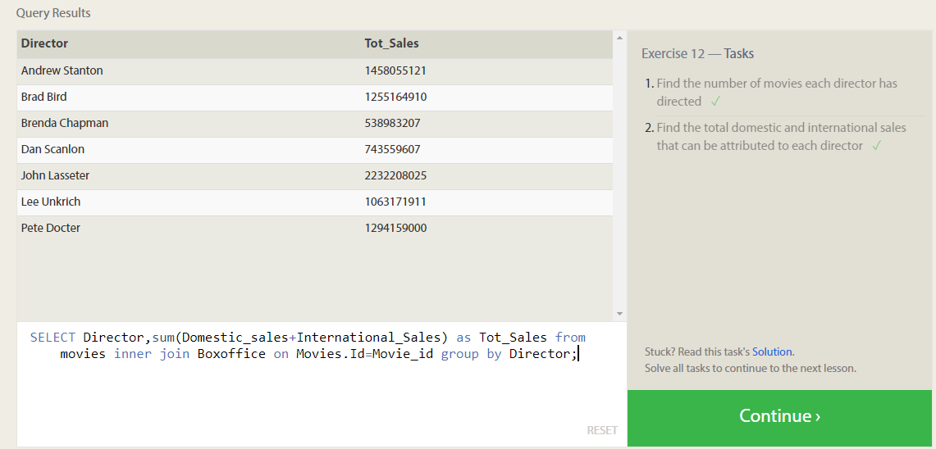

**SQL Lesson 13: Inserting rows**

1.INSERT into Movies (Title, Director, Year, Length_minutes) VALUES ('Toy Story 4', 'any director', 2024, 100);

2.Select id from Movies where Title ='Toy Story 4';

INSERT into Boxoffice (Movie_id,Rating, Domestic_sales , International_sales)

VALUES (18,8.7, 340000000, 270000000);

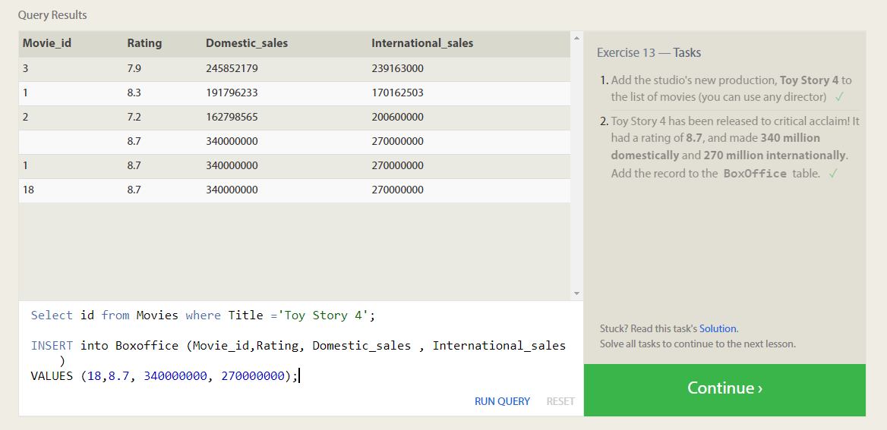

**SQL Lesson 14: Updating rows**

1.Update Movies set Director ='John Lasseter' where Title = "A Bug's Life";

2.Update Movies set Year ='1999' where Title = "Toy Story 2";

3.Update Movies set Title ='Toy Story 3',Director='Lee Unkrich' where Title = 'Toy Story 8';

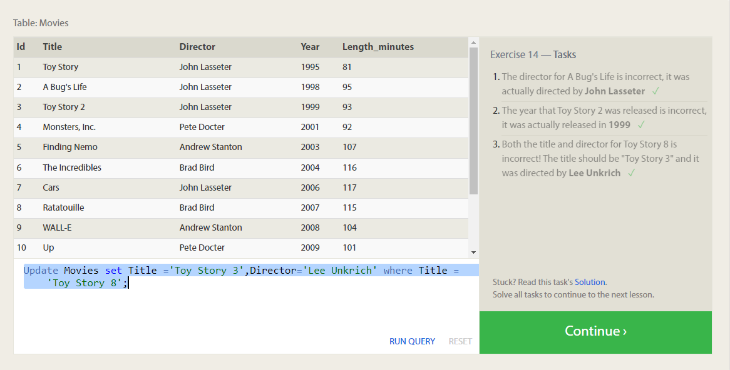

**SQL Lesson 15: Deleting rows**

1.Delete from movies where year<2005;

2.Delete from movies where Director ='Andrew Stanton';

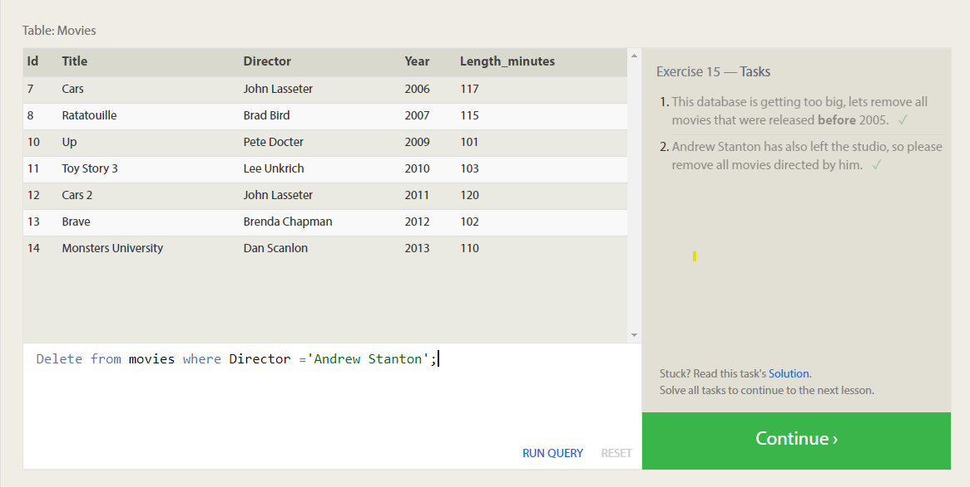

**SQL Lesson 16: Creating tables**

Create Table Database (

Name text,

Version float,

Download_count integer

);

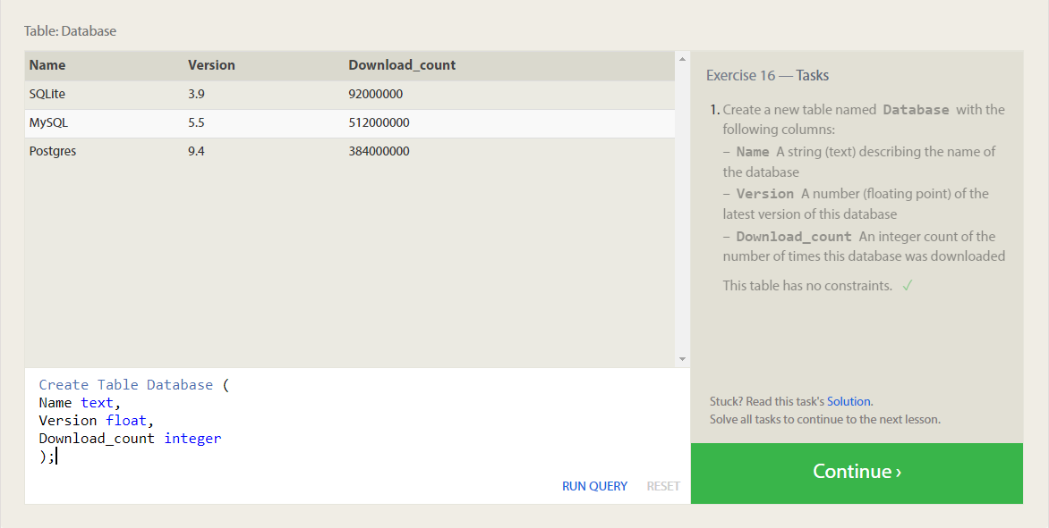

**SQL Lesson 17: Altering tables**

1.Alter Table Movies Add Aspect_ratio float;

2.Alter Table Movies Add Language text default 'English';

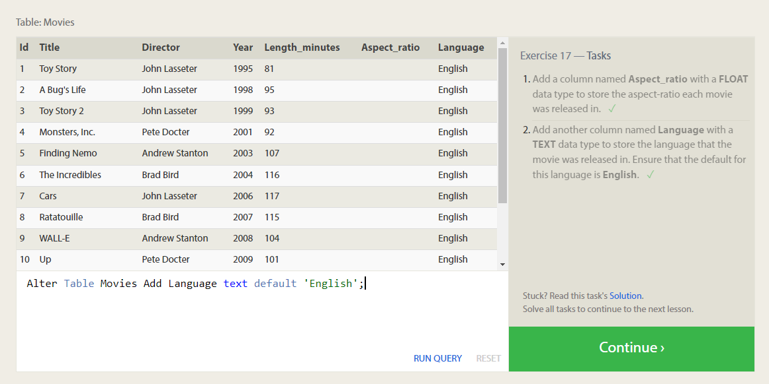

**SQL Lesson 18: Dropping tables**

1.Drop table if exists Movies;

2.Drop table if exists Boxoffice;

